**R Code for Examples in the book**

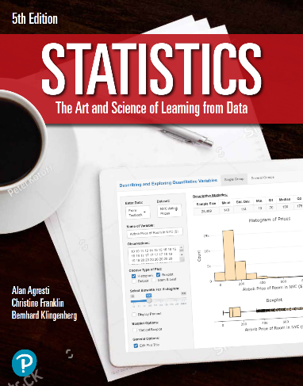

***“Statistics: The Art and Science of Learning from Data”***

**by Agresti, Franklin and Klingenberg, 5th edition**

**Chapter 13**

**Example 9: House Selling Price – Plotting Residuals**

## Reading in data

houses <- read.csv(file='https://raw.githubusercontent.com/artofstat/data/master/Chapter13/house_selling_prices_or.csv')

## Fitting in multiple regression model

linReg <- lm(HP.in.thousands ~ House.Size + Bedrooms, data = houses)  
linReg

##   
## Call:  
## lm(formula = HP.in.thousands ~ House.Size + Bedrooms, data = houses)  
##   
## Coefficients:  
## (Intercept) House.Size Bedrooms   
## 60.10214 0.06298 15.17041

## To obtain standardized residuals

mystdres <- rstandard(linReg)  
head(mystdres)

## 1 2 3 4 5 6   
## 0.2643425 0.6441210 -1.6377349 0.1023211 -0.3326797 1.9403118

## 

## To plot standardized residuals against house size

plot(mystdres ~ houses$House.Size, pch = 16, col = 'darkblue',  
 main = 'Residual Versus House Size',   
 xlab = 'House Size', ylab = 'Standardized Residual',  
 xlim = c(0, 12000), ylim = c(-5, 5))

